Assignment: Javascript Language

Scott Freedman

Ira A. Fulton Schools of Engineering, Arizona State University

IFT 458: Middleware Programming & Database Security

Professor Dinesh Sthapit

January 29, 2023

**Introduction to JavaScript – 1**

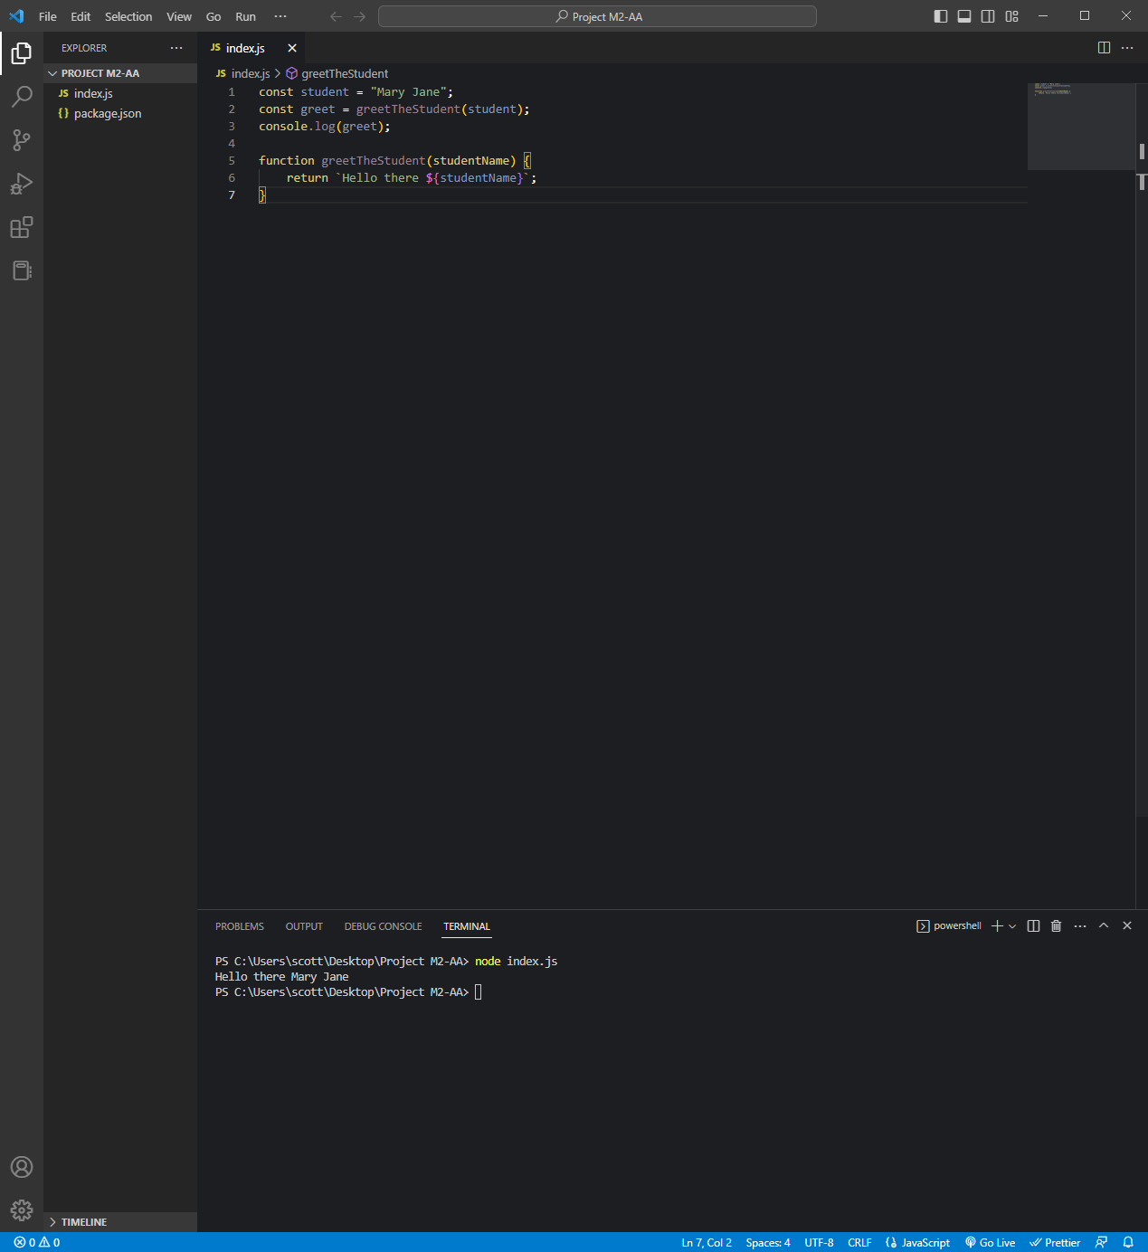

*Code:*

const student = "Mary Jane";

const greet = greetTheStudent(student);

console.log(greet);

function greetTheStudent(studentName) {

    return `Hello there ${studentName}`;

}

**JavaScript Function Refactoring 2**

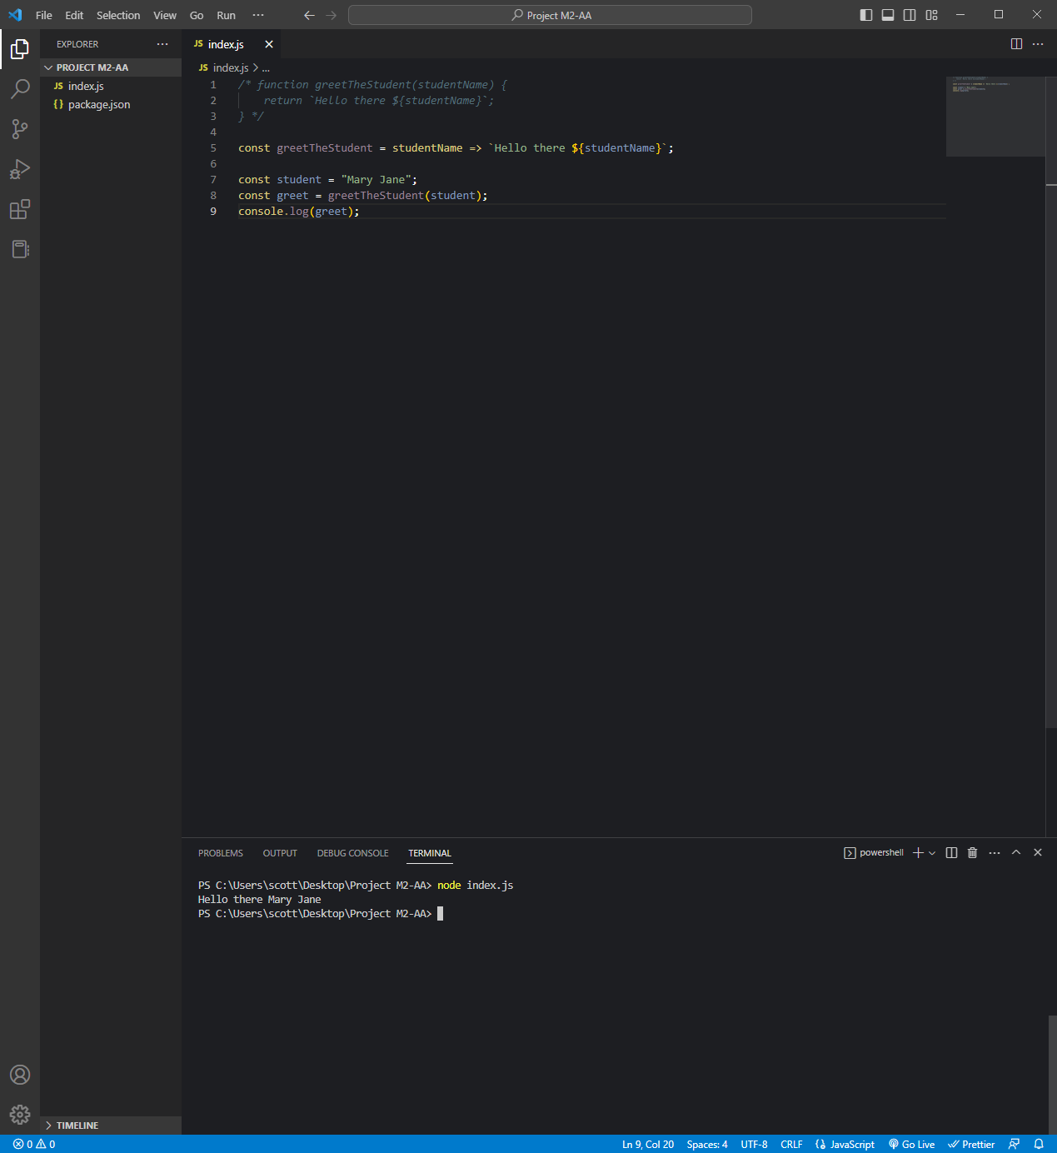

*Code:*

*/* function greetTheStudent(studentName) {*

*return `Hello there ${studentName}`;*

*} */*

const greetTheStudent = studentName => `Hello there ${studentName}`;

const student = "Mary Jane";

const greet = greetTheStudent(student);

console.log(greet);

**JavaScript Refactoring 3**

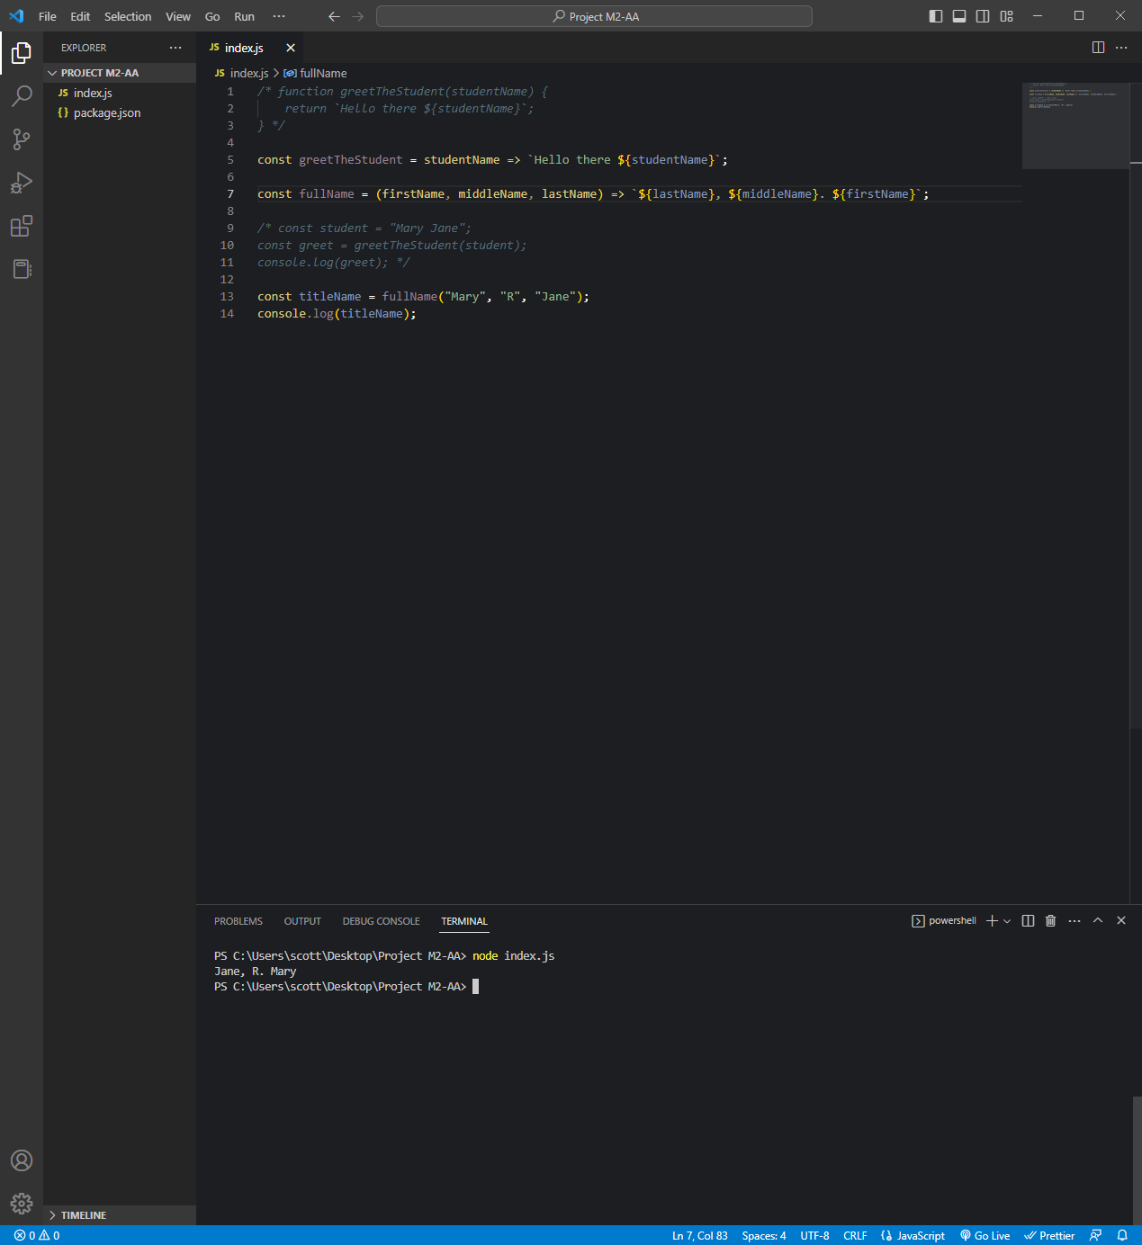

*Code:*

*/* function greetTheStudent(studentName) {*

*return `Hello there ${studentName}`;*

*} */*

const greetTheStudent = studentName => `Hello there ${studentName}`;

const fullName = (firstName, middleName, lastName) => `${lastName}, ${middleName}. ${firstName}`;

*/* const student = "Mary Jane";*

*const greet = greetTheStudent(student);*

*console.log(greet); */*

const titleName = fullName("Mary", "R", "Jane");

console.log(titleName);

**JavaScript Variables 4**

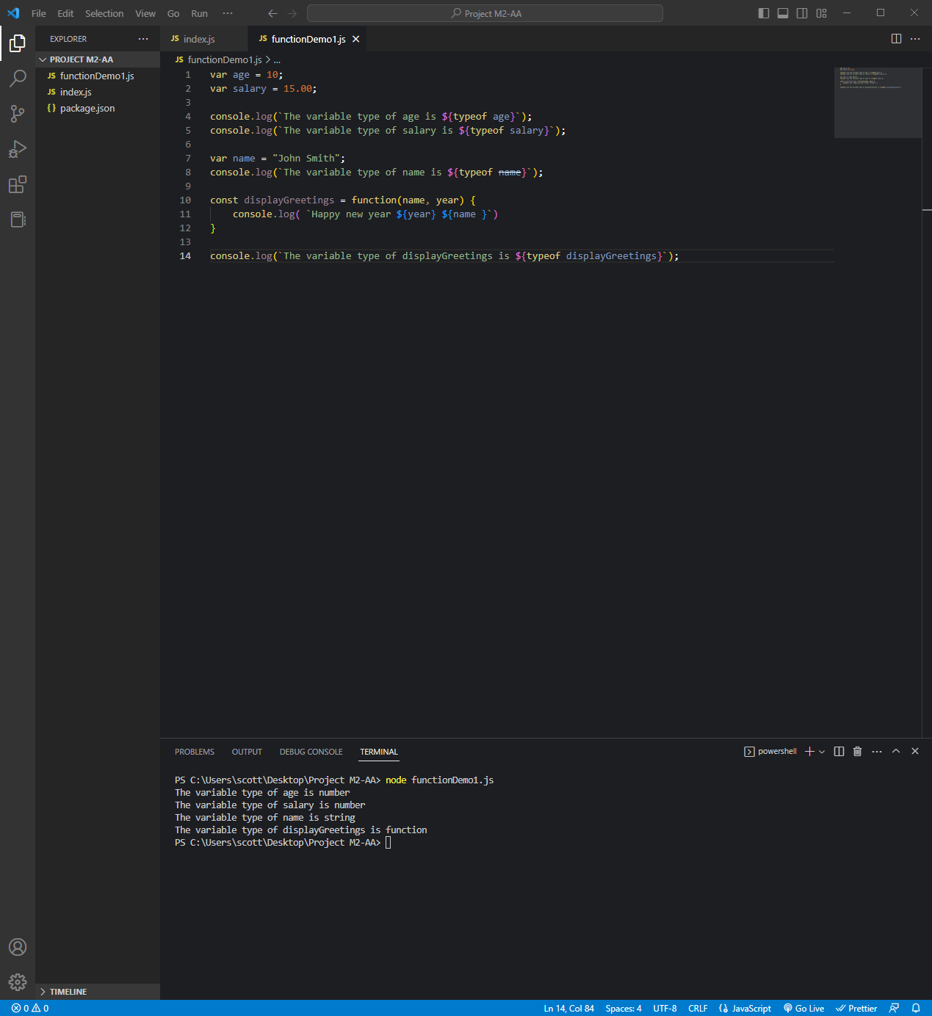

*Code:*

var age = 10;

var salary = 15.00;

console.log(`The variable type of age is ${typeof age}`);

console.log(`The variable type of salary is ${typeof salary}`);

var name = "John Smith";

console.log(`The variable type of name is ${typeof name}`);

const displayGreetings = function(name, year) {

    console.log( `Happy new year ${year} ${name }`)

}

console.log(`The variable type of displayGreetings is ${typeof displayGreetings}`);

**JavaScript Objects 5**

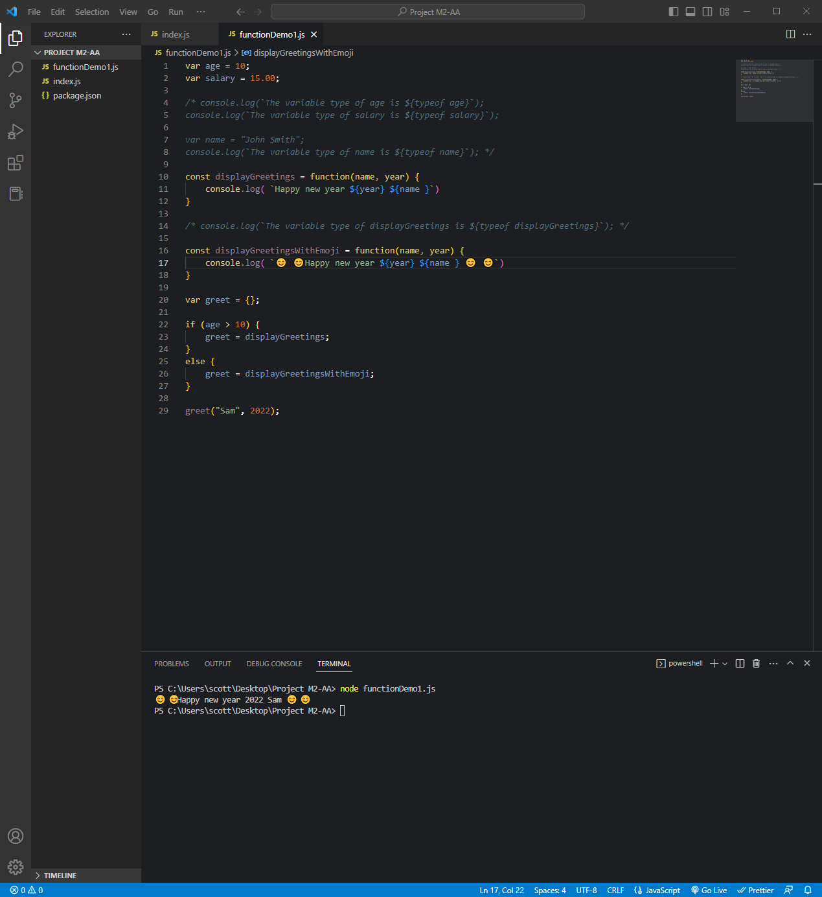

*Code:*

var age = 10;

var salary = 15.00;

*/* console.log(`The variable type of age is ${typeof age}`);*

*console.log(`The variable type of salary is ${typeof salary}`);*

*var name = "John Smith";*

*console.log(`The variable type of name is ${typeof name}`); */*

const displayGreetings = function(name, year) {

    console.log( `Happy new year ${year} ${name }`)

}

*/* console.log(`The variable type of displayGreetings is ${typeof displayGreetings}`); */*

const displayGreetingsWithEmoji = function(name, year) {

    console.log( `😊 😊Happy new year ${year} ${name } 😊 😊`)

}

var greet = {};

if (age > 10) {

    greet = displayGreetings;

}

else {

    greet = displayGreetingsWithEmoji;

}

greet("Sam", 2022);

**JavaScript Parameter (Function as a parameter) 6**

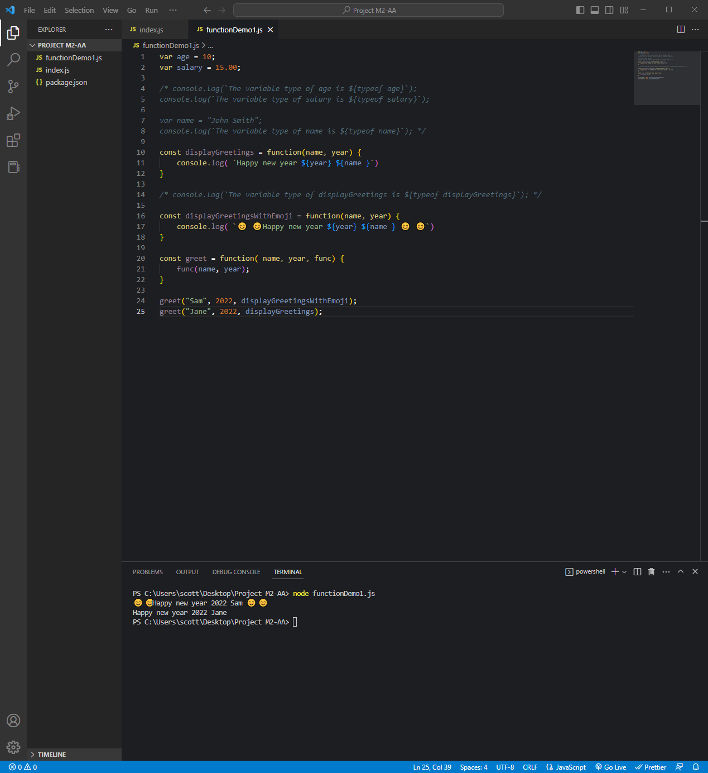

*Code:*

var age = 10;

var salary = 15.00;

*/* console.log(`The variable type of age is ${typeof age}`);*

*console.log(`The variable type of salary is ${typeof salary}`);*

*var name = "John Smith";*

*console.log(`The variable type of name is ${typeof name}`); */*

const displayGreetings = function(name, year) {

    console.log( `Happy new year ${year} ${name }`)

}

*/* console.log(`The variable type of displayGreetings is ${typeof displayGreetings}`); */*

const displayGreetingsWithEmoji = function(name, year) {

    console.log( `😊 😊Happy new year ${year} ${name } 😊 😊`)

}

const greet = function( name, year, func) {

    func(name, year);

}

greet("Sam", 2022, displayGreetingsWithEmoji);

greet("Jane", 2022, displayGreetings);

**JavaScript Objects II 8**

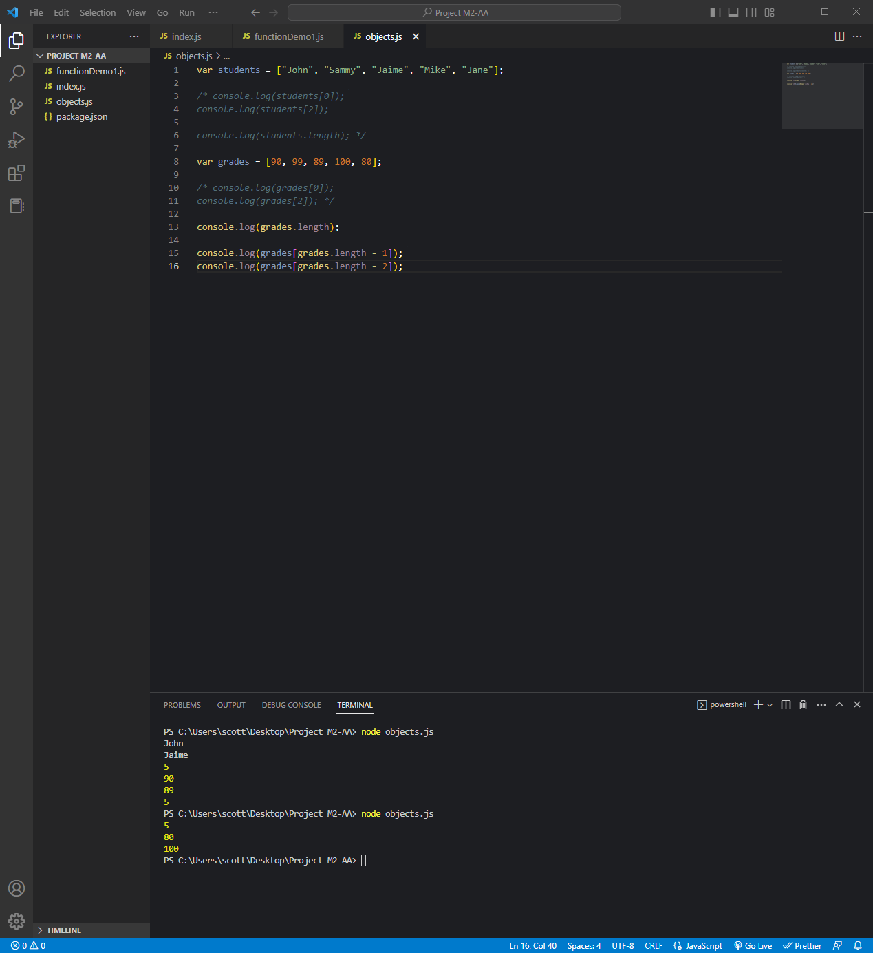

*Code:*

var students = ["John", "Sammy", "Jaime", "Mike", "Jane"];

*/* console.log(students[0]);*

*console.log(students[2]);*

*console.log(students.length); */*

var grades = [90, 99, 89, 100, 80];

*/* console.log(grades[0]);*

*console.log(grades[2]); */*

console.log(grades.length);

console.log(grades[grades.length - 1]);

console.log(grades[grades.length - 2]);

**JavaScript Arrays 9**

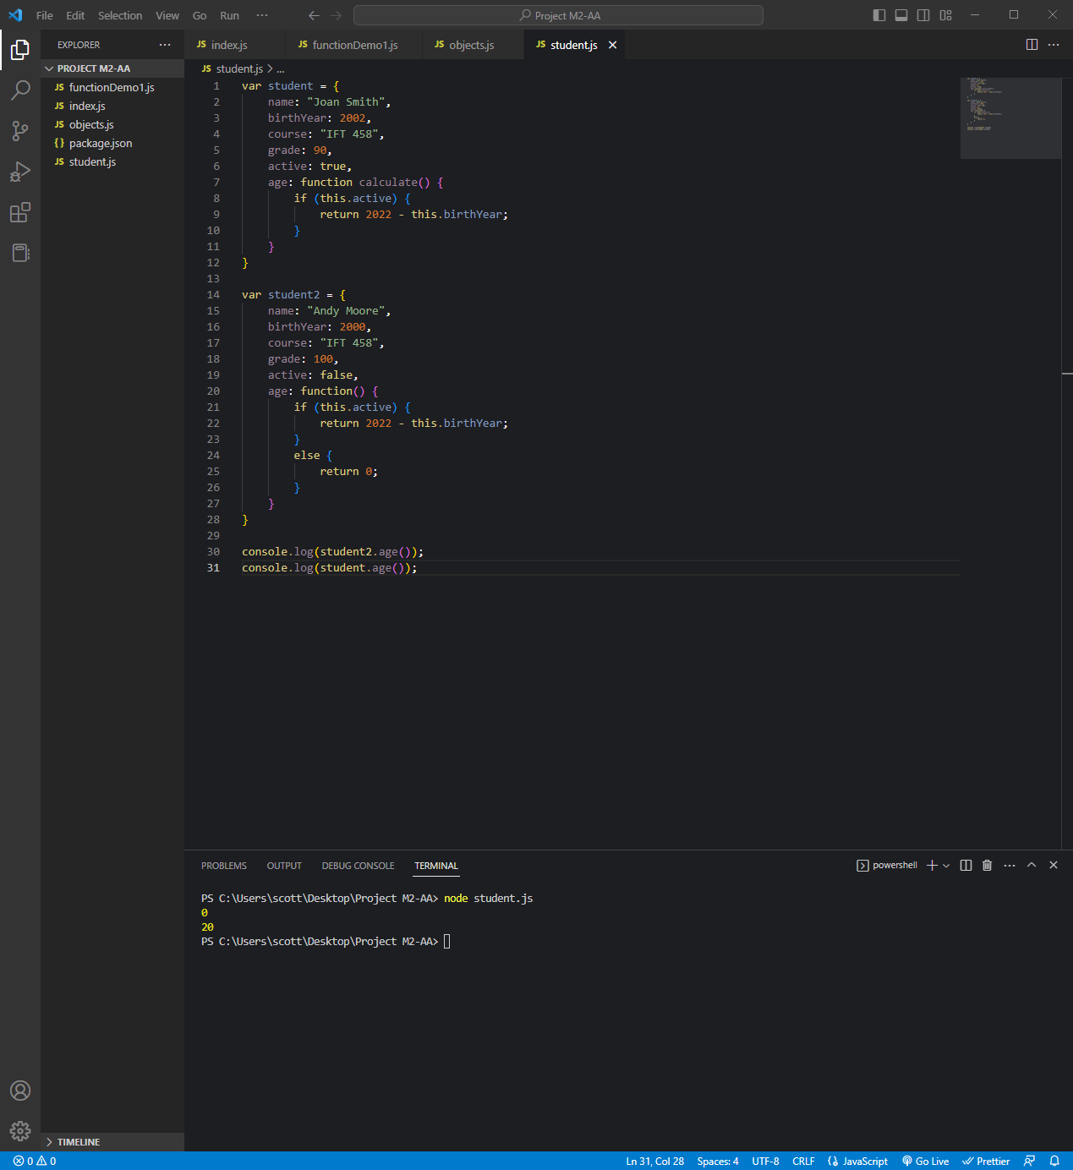

*Code:*

var student = {

    name: "Joan Smith",

    birthYear: 2002,

    course: "IFT 458",

    grade: 90,

    active: true,

    age: function calculate() {

        if (this.active) {

            return 2022 - this.birthYear;

        }

    }

}

var student2 = {

    name: "Andy Moore",

    birthYear: 2000,

    course: "IFT 458",

    grade: 100,

    active: false,

    age: function() {

        if (this.active) {

            return 2022 - this.birthYear;

        }

        else {

            return 0;

        }

    }

}

console.log(student2.age());

console.log(student.age());

**Accessing Elements of JavaScript Object Arrays 10**

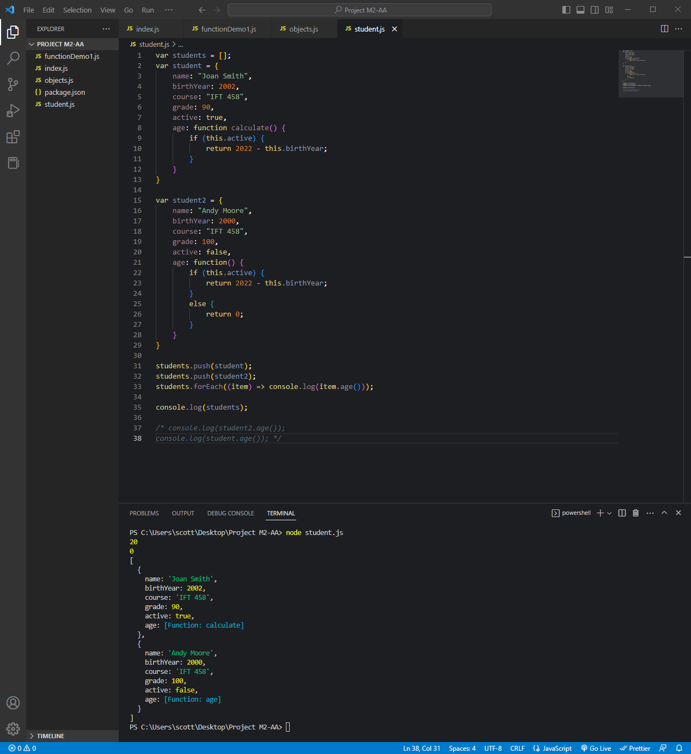

*Code:*

var students = [];

var student = {

    name: "Joan Smith",

    birthYear: 2002,

    course: "IFT 458",

    grade: 90,

    active: true,

    age: function calculate() {

        if (this.active) {

            return 2022 - this.birthYear;

        }

    }

}

var student2 = {

    name: "Andy Moore",

    birthYear: 2000,

    course: "IFT 458",

    grade: 100,

    active: false,

    age: function() {

        if (this.active) {

            return 2022 - this.birthYear;

        }

        else {

            return 0;

        }

    }

}

students.push(student);

students.push(student2);

students.forEach((item) => console.log(item.age()));

console.log(students);

*/* console.log(student2.age());*

*console.log(student.age()); */*